**ELaNa-XX Mission**

AMSAT-NA, the Radio Amateur Satellite Corp

**RadFxSat-2**

**Random Vibration Test Procedure**

## Change Log

|  |  |  |  |
| --- | --- | --- | --- |
| **Rev** | **Date** | **Author** | **Change Log** |
| 0 | 3/6/2017 | Robert Davis | Initial draft |
| 1 | 3/7/2018 | Robert Davis | Remove BYU’s PICs (was sharing a 3U TestPOD). |
| 2 | 3/9/2018 | Robert Davis | Cleanup of test fixture and test tolerances. |
| 3 | 5/27/2018 | Robert Davis | Title includes “Random”.  Duration 2 minutes per LSP since not specified by LV. Replace “protoqual” with “protoflight qualification”. |

**Purpose:** The purpose of this document is to outline the procedure for protoflight qualification random vibration testing of AMSAT’s RadFxSat-2. It is a 1U CubeSat. It will launch with additional CubeSat(s) in an Xtenti FRA-R3S TestPOD. RadFxSat-2 will test alone in a Cal Poly 1U TestPOD. Vibration testing is performed to show the CubeSat will survive the launch environment. The test will be performed at NTSBoxborough, MA.

1. **Random Vibration Environment Verified:**

CubeSats shall be qualified to the maximum predicted random vibration environment.

* **L1-VCLS-ICD-20** – Random Vibration

GEVS Qualification (14.1 Grms to qualify for 10 Grms).

Duration 2 minutes per axis; 3 axes.

1. **Visual Verifications:** Photographs and/or videos should be taken as directed by the procedures at a minimum. All photos and/or videos shall be archived for future reference regardless if they are to be included in the final test report or not. Good practice should be followed to ensure photos are properly centered and focused. Macro mode is suggested when applicable.
2. **Test Levels:**

CubeSats shall be subject to a random vibration test to ensure structural stability of the design and workmanship of assembly.

The random vibration Maximum Predicted Enveloped is defined as “GEVS” Acceptance (GSFC-STD-7000A Table 2.4-3, 10.00 Grms).

The random vibration Qualification is defined as “GEVS” Qualification (GSFC-STD-7000A Table 2.4-3, 14.12 Grms).

Protoflight Qualification levels are Qualification levels per GSFC-STD-7000A §2.4.2.

Protoflight Qualification durations are 2 minutes, per LSP-REQ-317.01B Table 1.

The ELaNa-XX MPE and Qualification Random Profiles are shown below in Figure 2.

The Protoflight Qualification Random Test Profile is shown below in Figure 2.

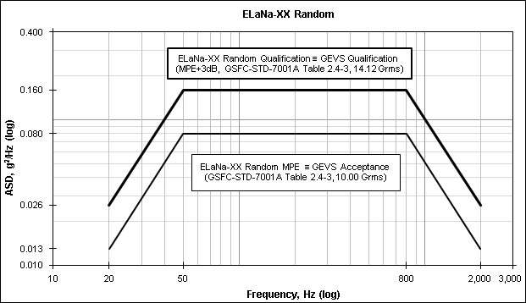

Figure ELaNa-XX Random MPE & Qualification Profiles

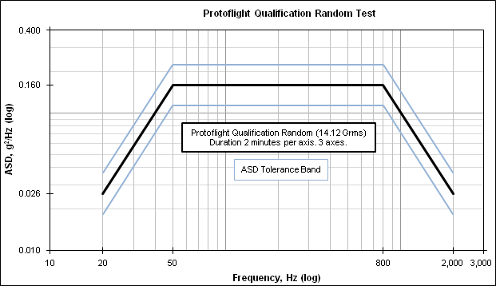

Figure 2 Protoflight Qualification Random Test Profile

Protoflight Qualification Random Test Profile is tabulated in Table 1.

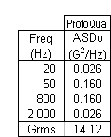

Table Protoflight Qualification Random Test Profile

Before and after each vibration event, a sine signature sweep shall be performed per Table 2.

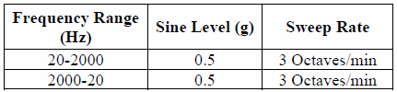

Table Sine Signature Sweep Profile

1. **Test Tolerances:**

Random Duration: Protoflight Qualification 1 minute per axis, per NASA-STD-7001A §4.3.3b.

Random Duration Tolerance: +10%/-0% (+12/-0 seconds), per GSFC-STD-7000A §1.13 and NASA-STD-7001A §4.3.4.1a(4).

Random Frequency Tolerance: +/-5%, per NASA-STD-7001A §4.3.4.1a(3).

ASD Tolerance (≤25 Hz bandwidths): +/-1.5dB on our own initiative.

This is tighter than +3/-1.5dB of NASA-STD-7001A ¶ following 4.3.4.1a(2) (which prevents Acceptance from exceeding Qualification).

This is tighter than +/-3 dB of GSFC-7000A §1.13 (which allows Acceptance to exceed Qualification).

Composite RMS Acceleration Tolerance: +/-10%, per GSFC-STD-7000A §1.13 and NASA-STD-7001A §4.3.4.1a(1).

These random vibration test tolerances are tabulated in Table 3.

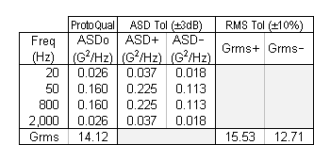

Table Random Test Tolerances

**Test Tolerance Exceedances**

During sine sweep of previous AMSAT CubeSats on slip table for horizontal axes, deviation from nominal level (and outside reasonable tolerance band) was observed.

On RadFxSat for ELaNa-14, using 1U Cal Poly Test POD at NTS Boxboro on Ling V-895, this was 1887 Hz. On RadFxSat, the sine sweep rate was not altered, but the test tolerance was waived in the region of 1887 Hz.

On Fox-1C & Fox-1D, using 1U ISIS Test POD at NTS Orlando on Ling 335, this was near 1730 Hz. On Fox-1C&D, the sine sweep was altered to 1 octave/minute, which resulted in perhaps 50% reduction.

This is thought to be a property of the test fixture/setup not the test article. Perhaps reducing the sweep rate from 3 octaves/minute to 1 octave/minute would reduce the magnitude of deviation by 50%. However, this strategy also exposes the flight article to greater dwell time near its own natural frequencies.

On RadFxSat-2, it is the test director’s discretion to address any sine sweep amplitude exceedances at the time of the test. Guidance is to proceed without altering sweep rate, and to increase the tolerance in the region of the exceedance.

**Comparing pre/post sine signature sweeps**

Compare pre/post sine signature sweeps before breaking test configuration of that axis.

Note any change of amplitude outside +/-10%.

Note any change in frequency outside +/-10%.

Settling does occur. Any amplitude or frequency anomaly should be noted, is warrant to review worthiness to continue testing, but is likely not indicative of “unseen” damage from structural load path variation that may plague complex structures.

1. **AMSAT’s RadFxSat-2**

RadFxSat-2 is a 1U CubeSat, approximately 1.33 kg (2.93 lb) and 112 x 112 x 113 mm (4.4 x 4.4 x 4.4 inches).

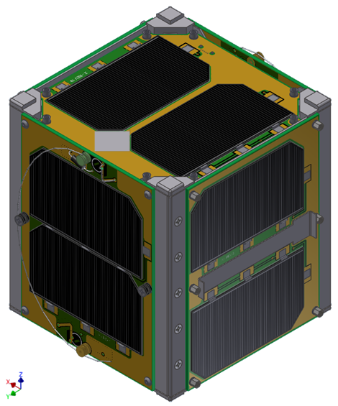

Figure RadFxSat-2 (Stowed as Launch Configuration) +Z,-X,+Y Sides (from top, clockwise)

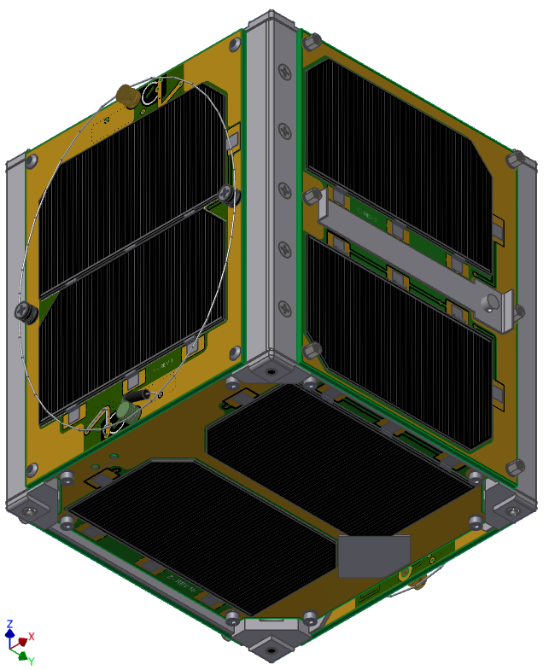

Figure RadFxSat-2 (Stowed as Launch Configuration) -Z, -Y, +X Sides (from bottom, clockwise)

1. **CubeSat Precautions**
2. CubeSats shall be maintained to Generally Clean (GC) level (freedom from manufacturing residue, dirt, oil, grease, processing debris or other extraneous contamination).
   1. All handling of CubeSats shall be with powder-free nitrile gloves.
   2. CubeSats shall be static-dissipative bagged for extended storage.
   3. CubeSats shall be static-dissipative tented for brief storage.
   4. If CubeSats inside, TestPOD holes shall be covered by Kapton tape before entering the (dusty, oily) air of the test lab, or before prolonged storage.
3. CubeSats are static electricity sensitive.
   1. All handling shall be while CubeSat and handler are grounded.
   2. All electrical support equipment shall be grounded.
   3. The test article of TestPOD with CubeSats inside is not static electricity sensitive.
4. CubeSats have pressure sensitive surfaces.
   1. Solar Cells crack and shall not be contacted directly.
   2. Solar Panel Covers shall be used whenever practical.
5. CubeSats have emitted RF.
   1. CubeSats shall remain powered off unless performing Short Function Test or Aliveness Test.
   2. Short Functional Test may include emitted RF.
   3. Aliveness Test (briefly pulling the RBF pin) does not include emitted RF.
   4. When emitting, personnel safe distance is defined as no direct contact with any (RX or TX) antennas.
   5. When emitting, CubeSat personnel shall always be present.
6. CubeSat unintended power on inside TestPOD can damage CubeSats.
   1. CubeSats shall remain powered off inside TestPOD during integration and de-integration, by installation of Safe RBF Pin.
   2. CubeSats shall remain powered off inside TestPOD during vibration table operations by TestPOD compression of both separation switches per CubeSat.
   3. CubeSats “power on” can be detected by lit LED in TestPOD holes, or by audible beeping. CubeSats do not pose any hazards to itself inside TestPOD during the first 50 minutes of power on.
   4. If CubeSats unintended “power on” inside TestPOD, install Safe RBF Pin. Suspend testing for further inspection of CubeSats and TestPOD.
7. CubeSat unintended RF transmission inside TestPOD.
   1. During vibration testing a suitable receiver will be used to monitor the CubeSat transmit frequency for any RF transmissions from the CubeSat.
8. **TestPOD**

RadFxSat-2 is vibration tested alone in launch configuration, but inside a 1U Test POD from Cal Poly instead of a flight FRA-R3S TestPOD.

The tested assembly is approximately 3.8 kg (8.4 lb), and 190 x 135 x 178 mm (7.5 x 5.3 x 7 inches).

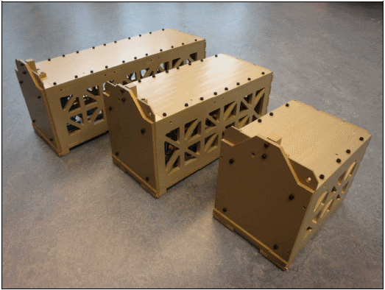

Figure Test Deployer (1U on the right)

1U TestPOD mounting interface is 4x M6, 70 x 106 mm. The TestPOD has helicoils intended for screw grip of 10-15 mm.

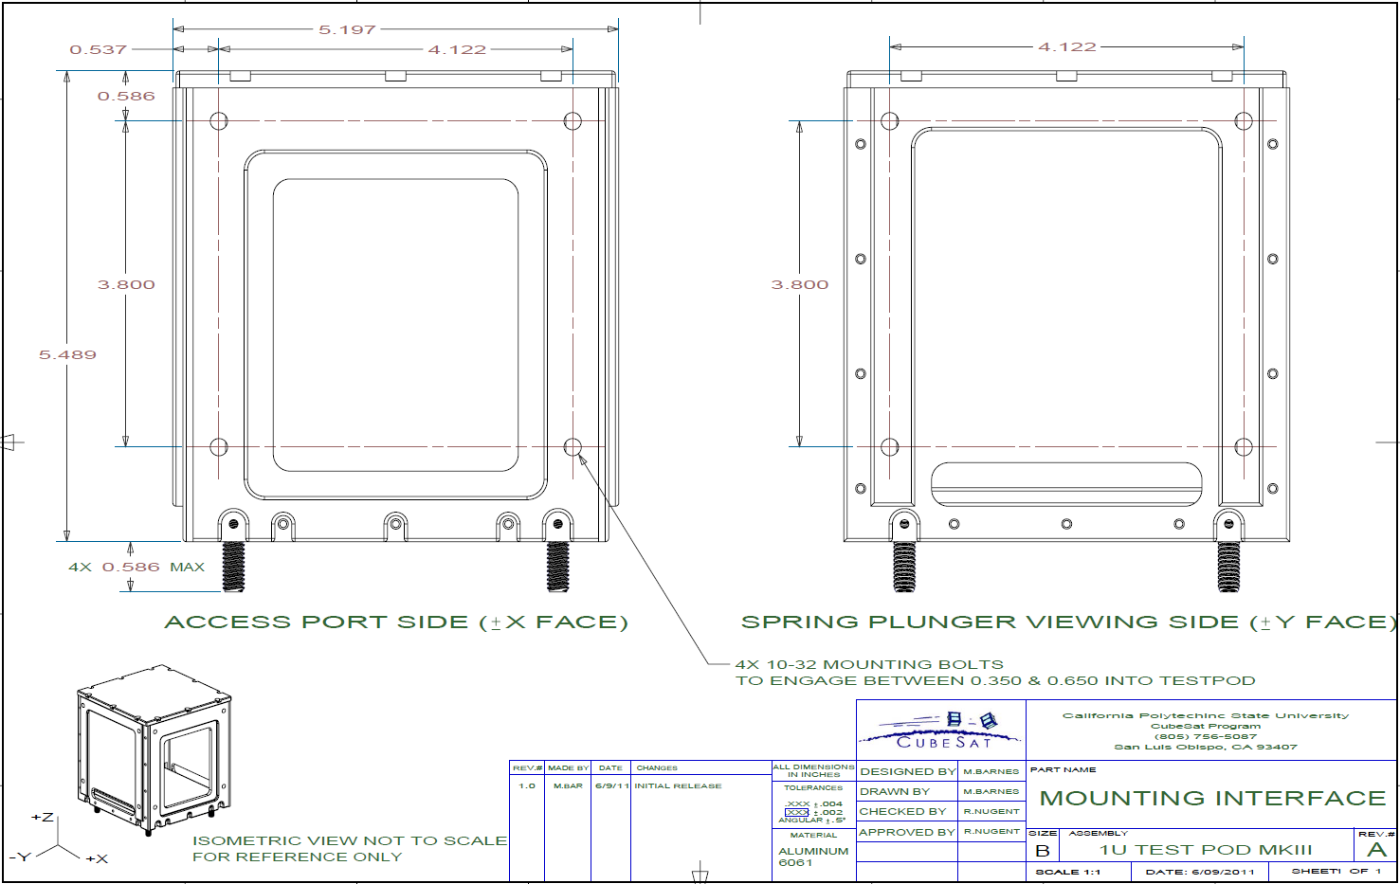

Figure TestPOD mounting bolt pattern



Figure CubeSats order and orientation inside TestPOD

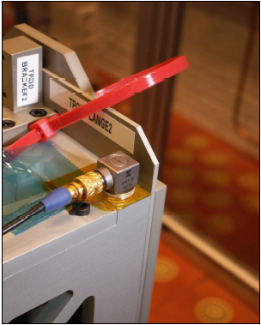

Figure 10 Recommended 3-axis accelerometer position

1. **Test Equipment:**

|  |  |
| --- | --- |
| **CubeSats** | RadFxSat-2, Flight Unit, IHU SN ___ |
| **Shaker System** | Ling V895 at  NTS Boxboro  1466 Massachusetts Ave  Boxborough, MA  978-266-1001 |
| **Accelerometers** | [Describe type, serial number, quantity] |
| **Data Acquisition** | [Describe type, serial number] |
| **Interface Plate** | Provided by NTS.  6061AL, 20”x10”x1”. See Figure 11. |
| **TestPOD** | Cal Poly’s 1U TestPOD S/N ___ |

Table Test Equipment

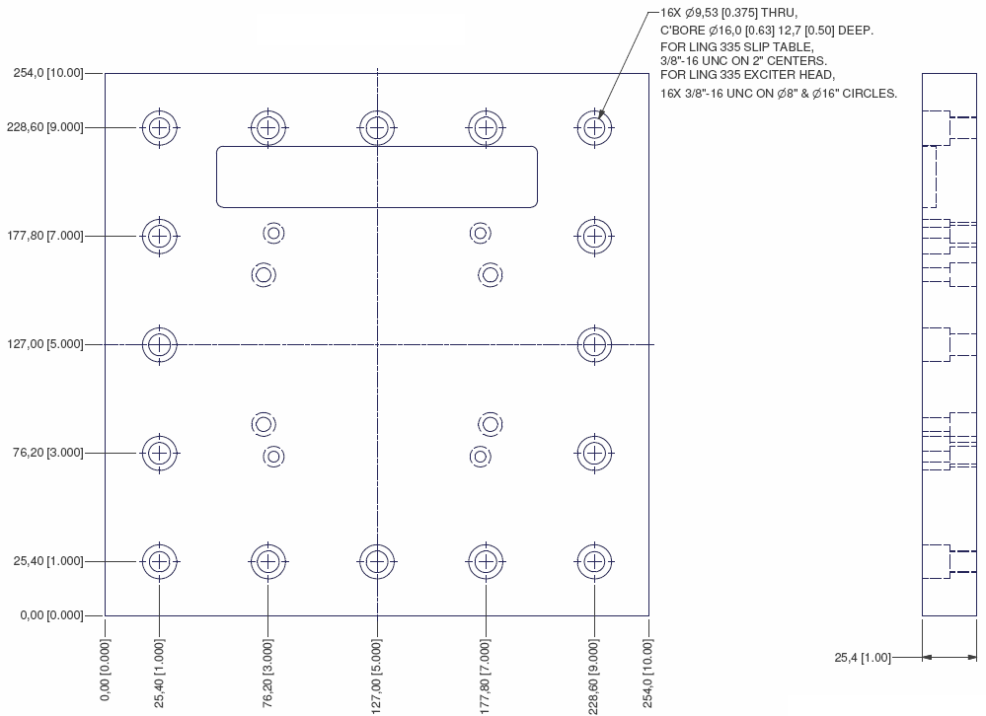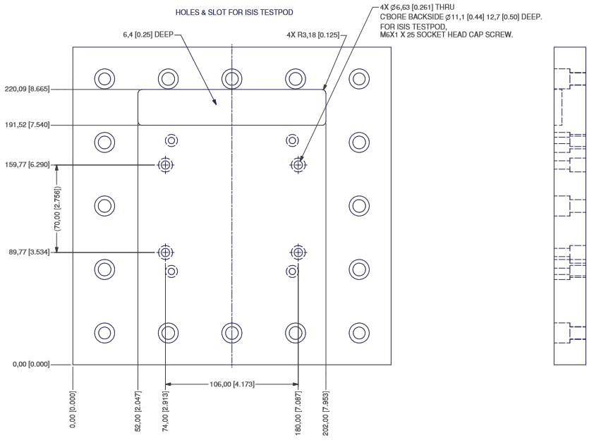

Figure 11 Interface Plate, FOX-ME-140

1. **Personnel:**

**AMSAT-NA’s RadFxSat-2 personnel present:**

Robert Davis, vibration test lead, mechanical lead.

Eric Skoog, electrical test, systems lead.

Burns Fisher, electrical test, software.

**NTS personnel present:**

Vibration test lead: ___________________________________

1. **Vibration Test Sequence**
   * X-Axis (Slip Table)
     1. Pre-sine sweep
     2. Random
     3. Post-sine sweep
   * Z-Axis (Slip Table)
     1. Pre-sine sweep
     2. Random
     3. Post-sine sweep
   * Y-Axis (Exciter Head)
     1. Pre-sine sweep
     2. Random
     3. Post-sine sweep

Order of test axes is arbitrary, but likely the order shown is optimal for test setup.

1. **Pre-Test Short Functional and Aliveness Tests (may be prior to test facility)**

|  |  |  |  |  |
| --- | --- | --- | --- | --- |
| **Step** | **Description** | **Time** | **Date** | **initial** |
|  | RadFxSat-2 IHU S/N ___ |  |  |  |
|  | Concur flight configuration, except Safe RBF Pin is installed and Solar Panel Covers are optional. |  |  |  |
|  | Perform Short Functional Test. |  |  |  |
|  | Verify Safe RBF Pin is installed. |  |  |  |
|  | Perform Aliveness Test. |  |  |  |
|  | Verify Safe RBF Pin is installed. |  |  |  |
|  | Perform CubeSat Acceptance Checklist. |  |  |  |
|  | Verify Safe RBF Pin is installed. |  |  |  |

1. **Optional Fit Check CubeSats in TestPOD (may be prior to test facility)**

|  |  |  |  |  |
| --- | --- | --- | --- | --- |
| **Step** | **Description** | **Time** | **Date** | **initial** |
|  | Record RadFxSat-2 IHU S/N ___ |  |  |  |
|  | Remove Solar Panel Covers |  |  |  |
|  | Concur flight configuration, except Safe RBF Pin is installed. |  |  |  |
|  | Record TestPOD S/N ___ |  |  |  |
|  | Install CubeSat per Section 6.1 Integration Procedure steps 1 through 7, of Cal Poly’s 1U TestPOD [Mk III] User’s Guide, rev 8.3. Align coordinate systems. |  |  |  |
|  | Take photos. |  |  |  |
|  | Remove CubeSat per TBD User’s Guide. |  |  |  |
|  | Bag CubeSats. |  |  |  |

1. **Optional Fit Check Empty TestPOD on Interface Plate**

|  |  |  |  |  |
| --- | --- | --- | --- | --- |
| **Step** | **Description** | **Time** | **Date** | **initial** |
|  | Record TestPOD S/N ___ |  |  |  |
|  | Record Interface Plate P/N _____________ and S/N ___ |  |  |  |
|  | Orient TestPOD on Interface Plate so engraved coordinate system is up. |  |  |  |
|  | Lightly tighten the four #10-32 fasteners from Interface Plate to TestPOD. Do not torque. |  |  |  |
|  | Do not proceed to vibration table. Do not vibrate. Remove the fasteners from the Interface Plate to TestPOD. |  |  |  |

1. **Integrate CubeSats in TestPOD**

|  |  |  |  |  |
| --- | --- | --- | --- | --- |
| **Step** | **Description** | **Time** | **Date** | **initial** |
|  | Record RadFxSat-2 IHU S/N ___ |  |  |  |
|  | Remove Solar Panel Covers |  |  |  |
|  | Concur flight configuration, except Safe Plug RBF is installed. |  |  |  |
|  | Record TestPOD S/N ___ |  |  |  |
|  | Integrate CubeSat per Section 6.1 Integration Procedure of Cal Poly’s 1U TestPOD [Mk III] User’s Guide, rev 8.3. For CubeSat orientation inside TestPOD, see Figure 9. |  |  |  |
|  | Receiver shall be tuned to UHF FM downlink of 435.750 MHz and be monitored for 65 minutes.  If during this time, RadFXSat-2 is heard to be transmitting:  Install Safe RBF Pin  Inspect RadFXSat-2 and TestPOD.  Next task may begin at any time during this monitoring for 65 minutes. Record time after 65 minutes. __________ |  |  |  |
|  | Remove the Safe RBF Pin. |  |  |  |
|  | Is RadFxSat-2 LED lit? Yes / No  Is RadFxSat-2 beeper heard? Yes / No  If Yes to either:  Install Safe RBF Pin.  Inspect RadFxSat-2 and TestPOD. |  |  |  |
|  | Take photos. |  |  |  |
|  | Apply kapton tape over all openings. |  |  |  |
|  | Take photos. |  |  |  |

1. **Pre-Test Inspection of Test Article**

|  |  |  |  |  |
| --- | --- | --- | --- | --- |
| **Step** | **Description** | **Time** | **Date** | **initial** |
|  | Inspect staking compound on visible fasteners and apply torque stripes where applicable. |  |  |  |
|  | Take photos of all sides of the TestPOD. |  |  |  |
|  | Attach the TestPOD onto the Interface Plate, TBD coordinate system, using the TBD washers and TBD screws. Torque to TBD N*m. |  |  |  |
|  | Ensure the RBF pin has been removed from each CubeSat. |  |  |  |
|  | Is RadFxSat-2 LED lit? Yes / No  Is RadFxSat-2 beeper heard? Yes / No  If Yes to either:  Install Safe RBF Pin.  Inspect RadFxSat-2 and TestPOD. |  |  |  |
|  | Take photos. |  |  |  |
|  | Tape all access ports, viewing windows, and unused bolt holes before leaving the clean area. |  |  |  |

1. **X-Axis Test Procedures**

|  |  |  |  |  |
| --- | --- | --- | --- | --- |
| **Step** | **Description** | **Time** | **Date** | **initial** |
|  | Attach the Vibration Table Interface Plate onto the Vibration Slip Table, so test is in TestPOD X-axis. Torque ______. |  |  |  |
|  | Attach the control accelerometer(s) on the interface plate and the response accelerometer(s) to the corresponding top corner of TestPOD. Take photos of the accelerometer placement showing the coordinate system markings with respect to the TestPOD orientation. |  |  |  |
|  | Take photos of the entire test setup (overall for test direction, closeup for control accelerometers, closeup for response accelerometers, closeup for door position). |  |  |  |
|  | Receiver shall be tuned to UHF FM downlink of 435.750 MHz and be monitored during vibration events plus 65 minutes.  If during this time, RadFXSat is heard to be transmitting:  Install Safe RBF Pin  Inspect RadFxSat-2 and TestPOD.  Next task may begin at any time during this monitoring for 65 minutes. |  |  |  |
|  | Perform sine signature sweep to the level specified in Table 2 and tolerances specified in Table 4.  Record Start Time: ___________  Record Stop Time: ___________ |  |  |  |
|  | Is RadFxSat-2 LED lit? Yes / No  Is RadFxSat-2 beeper heard? Yes / No  If Yes to either:  Install Safe RBF Pin.  Inspect RadFxSat-2 and TestPOD. |  |  |  |
|  | Visually inspect TestPOD door and mounting screws. |  |  |  |
|  | Perform random vibration test to the 14.12 Grms X-axis levels specified in Figure 2 and Table 1, for 2 minutes, and tolerances specified in Table 3.  Record Start Time: ___________  Record Stop Time: ___________  **Test within Tolerance, X-Axis**  🞎Passed 🞎Failed |  |  |  |
|  | Is RadFxSat-2 LED lit? Yes / No  Is RadFxSat-2 beeper heard? Yes / No  If Yes to either:  Install Safe RBF Pin.  Inspect RadFxSat-2 and TestPOD. |  |  |  |
|  | Visually inspect TestPOD door and mounting screws. |  |  |  |
|  | Perform sine signature sweep to the level specified in Table 2 and tolerances specified in Table 4.  Record Start Time: ___________  Record Stop Time: ___________ |  |  |  |
|  | Is RadFxSat-2 LED lit? Yes / No  Is RadFxSat-2 beeper heard? Yes / No  If Yes to either:  Install Safe RBF Pin.  Inspect RadFxSat-2 and TestPOD. |  |  |  |
|  | Visually inspect TestPOD door and mounting screws. |  |  |  |
|  | Reset timer for 65 minutes. Continue monitoring for UHF FM downlink of 435.750 MHz.  If during this time, RadFxSat-2 is heard to be transmitting:  Install Safe RBF Pin  Inspect RadFxSat-2 and TestPOD.  Next axis may begin at any time during this monitoring for 65 minutes. Record time after 65 minutes. __________ |  |  |  |
|  | Compare pre/post sine signature sweeps for changes in amplitude or frequency. |  |  |  |
|  | Record any anomalies or issues. |  |  |  |
|  | Take photos of the entire test setup (overall for test direction, closeup for control accelerometers, closeup for response accelerometers, closeup for door position). |  |  |  |

1. **Z-Axis Test Procedures**

|  |  |  |  |  |
| --- | --- | --- | --- | --- |
| **Step** | **Description** | **Time** | **Date** | **initial** |
|  | Rotate the Vibration Table Interface Plate slip table, so test is in TestPOD Z-axis. Torque ______. |  |  |  |
|  | Attach the control accelerometer(s) on the interface plate and the response accelerometer(s) to the corresponding top corner of TestPOD. Take photos of the accelerometer placement showing the coordinate system markings with respect to the TestPOD orientation. |  |  |  |
|  | Take photos of the entire test setup (overall for test direction, closeup for control accelerometers, closeup for response accelerometers, closeup for door position). |  |  |  |
|  | Receiver shall be tuned to UHF FM downlink of 435.750 MHz and be monitored during vibration events plus 65 minutes.  If during this time, RadFxSat-2 is heard to be transmitting:  Install Safe RBF Pin  Inspect RadFxSat-2 and TestPOD.  Next task may begin at any time during this monitoring for 65 minutes. |  |  |  |
|  | Perform sine signature sweep to the level specified in Table 2 and tolerances specified in Table 4.  Record Start Time: ___________  Record Stop Time: ___________ |  |  |  |
|  | Is RadFxSat-2 LED lit? Yes / No  Is RadFxSat-2 beeper heard? Yes / No  If Yes to either:  Install Safe RBF Pin.  Inspect RadFxSat-2 and TestPOD. |  |  |  |
|  | Visually inspect the TestPOD door and mounting screws. |  |  |  |
|  | Perform random vibration test to the 14.12 Grms Z-axis levels specified in Figure 2, for 2 minutes.  Record Start Time: ___________  Record Stop Time: ___________  **Test within Tolerance, Z-Axis**  🞎Passed 🞎Failed |  |  |  |
|  | Is RadFxSat-2 LED lit? Yes / No  Is RadFxSat-2 beeper heard? Yes / No  If Yes to either:  Install Safe RBF Pin.  Inspect RadFxSat-2 and TestPOD. |  |  |  |
|  | Visually inspect the TestPOD door and mounting screws. |  |  |  |
|  | Perform sine sweep according to the level specified in Table 2 and tolerances in Table 4.  Record Start Time: ___________  Record Stop Time: ___________ |  |  |  |
|  | Is Fox LED lit? Yes / No  Is Fox beeper heard? Yes / No  If Yes to either:  Install Safe RBF Pin.  Inspect RadFxSat-2 and TestPOD. |  |  |  |
|  | Visually inspect the TestPOD door and mounting screws. |  |  |  |
|  | Reset timer for 65 minutes, and continue to monitor for UHF FM downlink of 435.750 MHz.  If during this time, RadFxSat-2 is heard to be transmitting:  Install Safe RBF Pin  Inspect RadFxSat-2 and TestPOD.  Next axis may begin at any time during this monitoring for 65 minutes. Record time after 65 minutes. __________ |  |  |  |
|  | Compare pre/post sine signature sweeps for changes in amplitude or frequency. |  |  |  |
|  | Record any anomalies or issues. |  |  |  |
|  | Take photos of the entire test setup (overall for test direction, closeup for control accelerometers, closeup for response accelerometers, closeup for door position). |  |  |  |

1. **Y-Axis Test Procedures**

|  |  |  |  |  |
| --- | --- | --- | --- | --- |
| **Step** | **Description** | **Time** | **Date** | **initial** |
|  | Attach the Vibration Interface Plate onto the Exciter Head, so test is in TestPOD Y axis. Torque ______. |  |  |  |
|  | Attach the control accelerometer(s) on the interface plate and the response accelerometer(s) to the corresponding top corner of TestPOD. Take photos of the accelerometer placement showing the coordinate system markings with respect to the TestPOD orientation. |  |  |  |
|  | Take photos of the entire test setup (overall for test direction, closeup for control accelerometers, closeup for response accelerometers, closeup for door position). |  |  |  |
|  | Receiver shall be tuned to UHF FM downlink of 435.750 MHz and be monitored during vibration events plus 65 minutes.  If during this time, RadFxSat-2 is heard to be transmitting:  Install Safe RBF Pin  Inspect RadFxSat-2 and TestPOD.  Next task may begin at any time during this monitoring for 65 minutes. |  |  |  |
|  | Perform sine signature sweep according to the level specified in Table 2 and tolerances specified in Table 4.  Record Start Time: ___________  Record Stop Time: ___________ |  |  |  |
|  | Is RadFxSat-2 LED lit? Yes / No  Is RadFxSat-2 beeper heard? Yes / No  If Yes to either:  Install Safe RBF Pin.  Inspection RadFxSat-2 and TestPOD. |  |  |  |
|  | Visually inspect the TestPOD door and mounting screws. |  |  |  |
|  | Perform random vibration test to the 14.12 Grms Y-axis levels specified in Figure 2 and Table 1, for 2 minutes, and tolerances specified in Table 3.  Record Start Time: ___________  Record Stop Time: ___________  **Test within Tolerance, Y-Axis**  🞎Passed 🞎Failed |  |  |  |
|  | Is RadFxSat-2 LED lit? Yes / No  Is RadFxSat-2 beeper heard? Yes / No  If Yes to either:  Install Safe RBF Pin.  Inspect RadFxSat-2 and TestPOD. |  |  |  |
|  | Visually inspect the TestPOD door and mounting screws. |  |  |  |
|  | Perform sine signature sweep according to the level specified in Table 2 and tolerances specified in Table 4.  Record Start Time: ___________  Record Stop Time: ___________ |  |  |  |
|  | Is RadFxSat-2 LED lit? Yes / No  Is RadFxSat-2 beeper heard? Yes / No  If Yes to either:  Install Safe RBF Pin.  Inspect RadFxSat-2 and TestPOD. |  |  |  |
|  | Visually inspect the TestPOD door and mounting screws. |  |  |  |
|  | Reset timer for 65 minutes, and continue to monitor for UHF FM downlink of 435.750 MHz.  If during this time, RadFXSat-2 is heard to be transmitting:  Install Safe RBF Pin  Inspect RadFXSat-2 and TestPOD.  Next activity may begin at anytime during this monitoring for 65 minutes. Record time after 65 minutes. __________ |  |  |  |
|  | Compare pre/post sine signature sweeps for changes in amplitude or frequency. |  |  |  |
|  | Record any anomalies or issues. |  |  |  |
|  | Take photos of the entire test setup (overall for test direction, closeup for control accelerometers, closeup for response accelerometers, closeup for door position). |  |  |  |
|  | Remove the Interface Plate with TestPOD from the Expander Head. |  |  |  |

1. **Post-Test Inspection of Test Article**

|  |  |  |  |  |
| --- | --- | --- | --- | --- |
| **Step** | **Description** | **Time** | **Date** | **initial** |
|  | Before proceeding, allow any timers to expire monitoring 65 minutes after final test axis for UHF FM downlink of 435.750 MHz. |  |  |  |
|  | Install Safe RBF Pin. |  |  |  |
|  | Remove CubeSats from TestPOD using TBD User’s Guide. |  |  |  |
|  | Visually inspect RadFxSat-2. |  |  |  |
|  | Perform Short Functional Test. |  |  |  |
|  | Verify Safe RBF Pin is installed. |  |  |  |
|  | Perform Aliveness Test. |  |  |  |
|  | Verify Safe RBF Pin is installed. |  |  |  |
|  | Perform CubeSat Acceptance Checklist. |  |  |  |
|  | Verify Safe RBF Pin is installed. |  |  |  |
|  | Bag CubeSats. |  |  |  |